**SIR ISSUE**

ISSUE: SIR ISSUE

Sample Ticket: 000000273659335

Case Id: 6657698

Solution:

Step-1: Check contact2address is available for below using below query.

DSL End User,

DSL CPOC,

DSL Billing,

DSL Building Contact

select table_case.id_number

,table_case.creation_time

,table_site.site_id

,table_Contact_role.role_name

,table_contact.objid as contact_objid

,table_contact.contact2address

,table_site.cust_primaddr2address

,table_site.cust_billaddr2address

,table_site.cust_shipaddr2address

,table_site.primary2bus_org

,table_case.case2address

from table_site,table_case,table_Contact_role,table_contact

where

table_case.id_number in (

'6657698'

)

AND table_case.case_reporter2site = table_site.objid

AND table_Contact_role.contact_role2site= table_site.objid

AND table_contact.objid = table_Contact_role.contact_role2contact;

Step 2: If not available ask BRASS team to get JSON request for the DSL order.

Step 3: After getting JSON request like below.

"Installation_Contact" : {

"Installation_Contact_Person_Name" : {

"First" : "Jacques Saintlouis",

"Last" : "1494124772",

"Company_Name" : "EarthLink"

},

"Installation_Contact_Address" : {

"Street1" : "980 Hammond Drive Suite 400",

"City" : "Atlanta",

"State" : "GA",

"Zip" : "30328",

"Telephone" : "8663001508",

"Email" : "ipbb@lists.corp.earthlink.net"

}

Step 4: Then run the following query to get cotact2address.

SELECT * FROM table_address where address='980 Hammond Drive Suite 400' and zipcode='30328';

From the above query result take the objid and update that objid in contact2address as below.(note:objid of the above query is the contact2address of the below.)

Step 3: After getting all information. Update accordingly using CONTACT_OBJID.

update table_contact set contact2address='xxxxxxxx' where objid='xxxxxxxx';

commit;

Step 4: After updating all contact2address we need retrigger SIR.

Below are steps to retrigger SIR.

How to retrigger from GUI in BBW?­­  
(https://bbw.it.att.com/ui/)  
  
1. Open BBW GUI and search with Case ID

Then press ctrl +shift+ y to yank a case

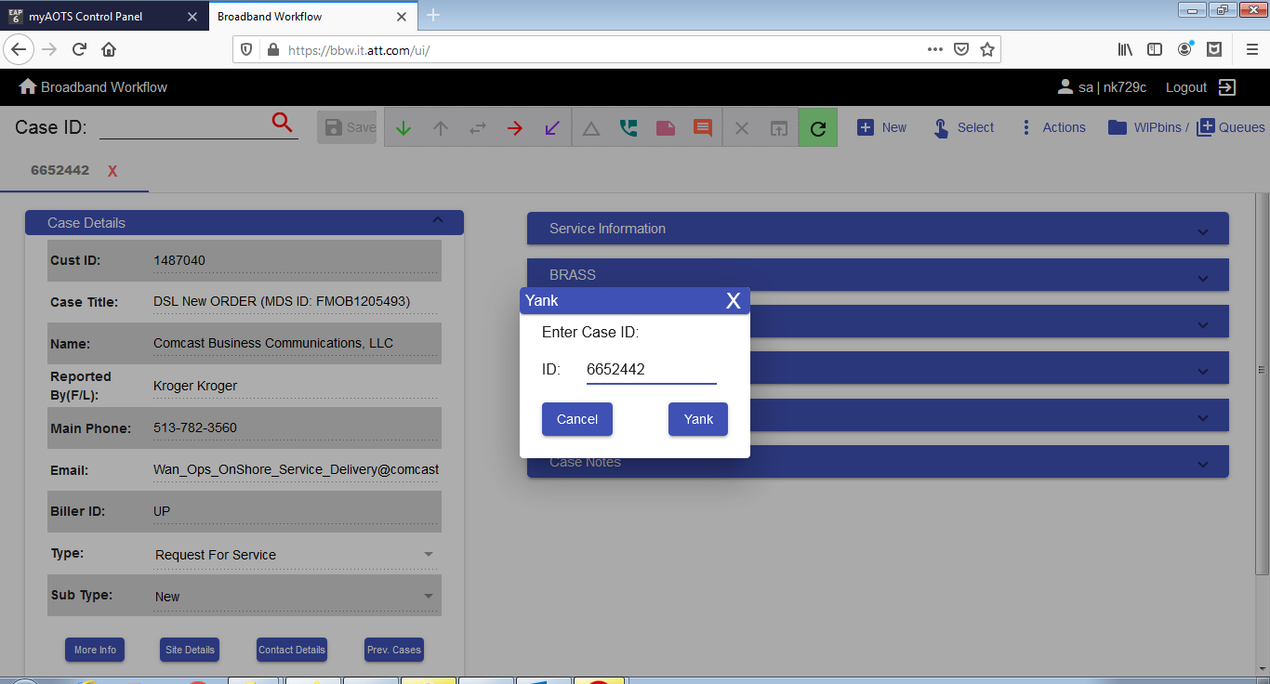

2. Go to BRASS tab, scroll down and click on SIR

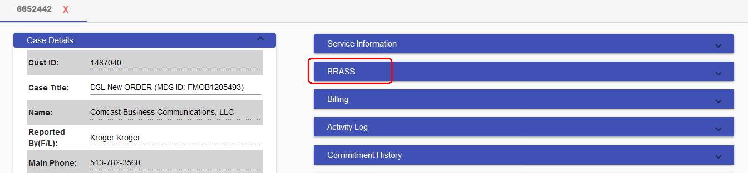

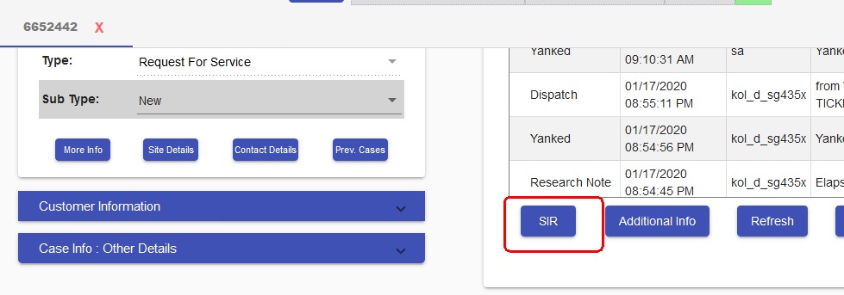

3. Click yes on the subsequent tab

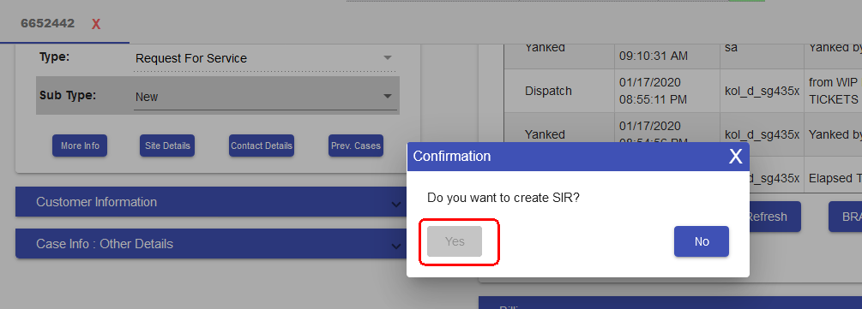

4. Then check below success message.(TX-ERROR and TX-STATUS)

